**CH 245: ORGANIC CHEMISTRY I LABORATORY (Fall 2019)**

**Title:**

1. **Purpose: (1 point)**

**To analyze the active ingredient in 4 different analgesics, identify an unknown active ingredient in a mixture, compare the effect of a solvent on a calculated Rf value, and to learn about the process of Thin Layer Chromatography.**

1. **Drawing of structure of the main compound or balanced chemical equation if synthesis is performed: (1 point)**

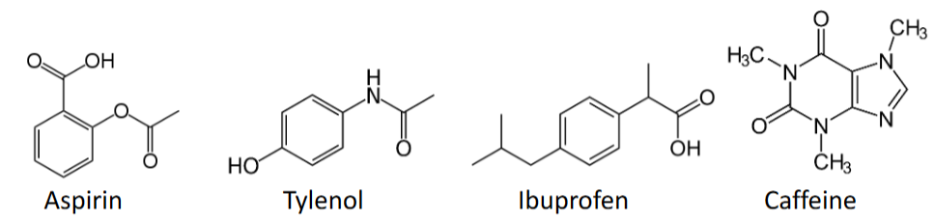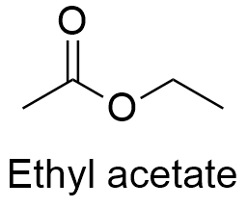

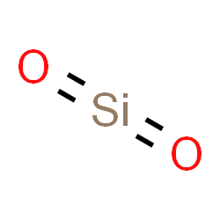 Silica

**3. Reagents and the major product (up to 5 points)**

|  |  |  |  |  |  |  |
| --- | --- | --- | --- | --- | --- | --- |
| **Name** | **M.W.**  (0.5 pts) | **Density**  (0.5 pts) | **Amount (grams/mL)**  (0.5 pts) | **Moles**  (0.5 pts) | **Hazards/Precautions**  **(MSDS data) and melting point or boiling point** (2 pts) | **Role of the reagent\*** (1 pts) |
| Aspirin | 180.158 | 1.4 g/cm3 | N/A | N/A | Harmful if swallowed, causes skin and eye irritation | Reactant |
| Tylenol | 151.163 | 1.29. g/cm3 | N/A | N/A | Slight skin and eye irritant | Reactant |
| Ibuprofen | 206.27 | 1.03 g/cm3 | N/A | N/A | Harmful if swallowed, causes serious eye irritation | Reactant |
| Caffeine | 194.096 | 1.23 g/cm3 | N/A | N/A | Toxic if swallowed | Reactant |
| Ethyl Acetate | 88.11 | 0.902 g/cm3 | N/A | N/A | Highly flammable, causes serious eye irritation | Solvent |
| Hexane | 86.18 | 0.659 g/cm3 | N/A | N/A | Highly flammable, may be fatal if swallowed, causes serious skin and eye irritation | Solvent |
| Silica | 60.08 | 2.65 g/cm3 | N/A | N/A | Respiratory irritation and skin and eye irritation | N/A |

**For Role of the reagent*, Choose from the following options:**

**Reactant, Product, Solvent, Drying agent, Catalyst**

**4. Calculations: (1 point)**

Show each calculation for moles of reagents and for theoretical and actual yield. Fill in the box with the limiting reagent and theoretical yield:

The limiting reagent is

The theoretical yield is

**5. Procedure (up to 2 points)**

|  |  |
| --- | --- |
| **Procedure** | **Observations and Lab Data** |
| A summary of the procedure done with bullet points) | Color changes, exothermic or endothermic reactions, gas generation, etc.; tare weights for flasks, etc. |
| * Line a TLC bottle with folded filter paper. * Add just enough ethyl acetate to cover the bottom of the bottle by 2-3 mm. Cover bottle and set aside. * Draw two light pencil lines on the TLC plates 1 cm from the bottom and top. Draw lines on coated sides. * Take a small amount of the four knowns in separate labeled beakers and add a small amount of hexane. * Using a capillary tube, spot place small spots on the starting line of the first plate. Do 2-3 substances on each plate. * Develop the chromatogram by placing the treated plates in the chamber, making sure the edges do not touch the sides of the bottle and that the bottom spotting line is above the solvent. * Allow the solvent to rise up the plate by capillary action until the solvent reaches the top line. * Remove the plate from the chamber and allow it to dry for 1-2 minutes. Place next plate in chamber while waiting, and repeat until all substances have been tested. * Bring each developed plate to be viewed under UV radiation. Mark the developed spots with a pencil and measure the Rf values and record. * Continue until clear values are obtained, at least two trials per substance. * Repeat with unknown substance and calculate Rf value of unknowns. * Identify unknown active compound by comparing with known Rf values. * If inconclusive, repeat with 50% ethyl acetate and 50% hexane as developing solvent. * Repeat procedure with aspirin and this new solvent. |  |

**6.** Results; include actual yield in grams and % yield.

**Results (need to get signed by instructor or TA):**